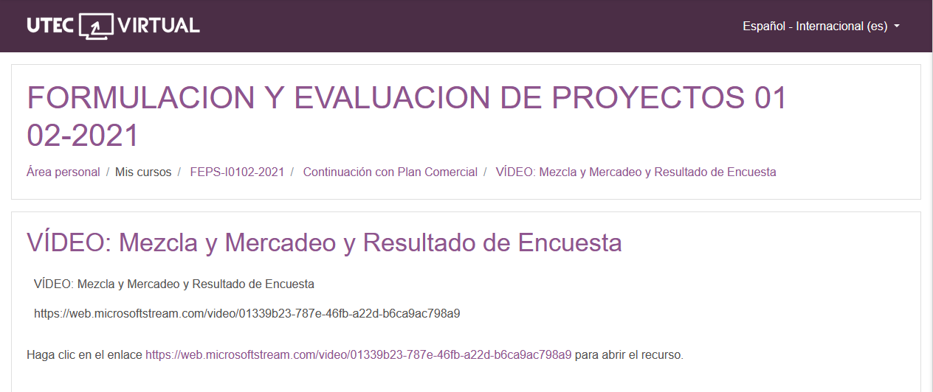

<https://web.microsoftstream.com/video/01339b23-787e-46fb-a22d-b6ca9ac798a9>